Determination of ammonium in 2M KCl soil extracts by FIAstar 5000

1. Scope and field of application
This Application Note describes a method for determination of ammonium in soil extracts in the following range:

0.1-5 mg/l NH₄-N in the extract (40 μl loop), linear calibration*

* Higher ranges may be obtained by adding more buffer to reagent 2 (3.10). See Remarks 5.9.2.
2. Principle of the method
Ammonium in the soil sample is extracted by 2M KCl. The suspension is centrifuged and filtered and can after this treatment be introduced in a flow injection system.
The soil sample extract is injected into a carrier stream, which is merged with a Sodium Hydroxide stream. In the resulting alkaline stream gaseous Ammonia is formed which may diffuse through a gas permeable membrane into an indicator stream. This indicator stream comprises a mixture of acid-base indicators, which will react with the Ammonia gas. A colour shift results which can be measured photometrically.
3. Reagents
Before using any chemicals refer to adequate manuals or safety data sheets approved by your local authorities. If not stated otherwise, only reagents of recognised analytical grade and water according to grade 1 of ISO 3696 shall be used.

3.1 Indicator mixture (Part No 5000 0295), inlcuded in the Method Cassette Accessory kit.
3.2 Distilled water
3.3 Sodium Hydroxide, NaOH
3.4 Ammonium Chloride, NH₄Cl, dried to constant mass at 105ºC
3.5 Potassium Chloride, KCl

3.6 2M Potassium chloride, KCl
In a suitable container, dissolve Potassium chloride in water. For preparation of this solution, see table
Volume | KCl
1 l | 149.1 g
5 l | 745.5 g
10 l | 1491 g
20 l | 2982 g

3.7 Indicator stock solution
Dissolve 1 g Ammonium indicator mixture in 50 ml 0.01M NaOH.and mix well. Dilute to 200 ml with distilled water. Filter off un-dissolved matter.
(0.01M NaOH: Dissolve 0.2 g Sodium Hydroxide in 500 ml distilled water.)
This solution is stable for 3 months if stored in a dark bottle.
3.8 Carrier solution, 2M KCl
See 3.6
3.9 Reagent , 0.5 M NaOH
Dissolve 10.0 g Sodium Hydroxide in 500 ml distilled water
3.10 Reagent , Indicator solution
Dilute 10ml of Indicator Stock Solution to 500ml with distilled water. Prepare 1 day prior to use. The absorbance of this solution must be checked before use, see 5.5. This solution is stable for at least 2 weeks.
3.11 Stock standard solution, 1000 mg/l NH₄-N
Dry Ammonium Chloride for 2 hours at 105 ºC. Dissolve 3.819 g Ammonium Chloride in distilled water and dilute to 1000 ml in a volumetric flask. The stock standard solution is stable for months.
3.12 Interim stock standard I, 20 mg/l NH₄-N
Pipette 10 ml of the stock standard solution into a 500 ml volumetric flask and dilute to volume with 2 M KCl. This solution should be prepared fresh daily.
3.13 Calibrating solutions
The calibrating solutions are prepared by diluting the solution described in 3.12 with 2 M KCl. At least five calibration standards per working range are recommended.

Working range 0.1-5 mg/l NH₄-N
NH₄-N concentration  mg/l | Volume interim standard (3.12)  Ml | Final volume  ml
0 | - | 100
0.1 | 0.5 | 100
0.5 | 2.5 | 100
1 | 5 | 100
2 | 10 | 100
5 | 25 | 100

The calibrating solutions should be prepared fresh daily.
4. Apparatus
Usual laboratory apparatus and

4.1 FIAstar 5000 Analyzer unit.
4.2 Method cassette NH₄ including gas diffusion cell and gas diffusion membrane+interference filters 590 nm and 720 nm.
4.3 5027 Sampler (optional)
4.4 Volumetric flasks, of nominal capacity 100 ml, 200, 500 ml and 1000 ml.
4.5 Pipettes of nominal capacity 0.5-25 ml
4.6 Shaking machine
4.7 Centrifuge
4.8 Filter paper, type Whatman No. 1 or Munktell No. 4.
4.9 Teflon diffusion membranes Part No 5000 2875

5. Procedure
5.1 Sampling and sample preparation
Weigh in 10 g air-dried soil into a 100 ml flask. Add 50 ml of 2M KCl and shake for one hour. Transfer the suspension to a centrifuge tube and centrifuge for 5 min, and/or filter the supernatant solution through Whatman No. 1 or Munktell No. 4 washed filter paper.

5.2 Starting up the system
- Power on all FIA modules and (if used) the 5027 Sampler.
- Verify that the correct method cassette, corresponding detector filters and loops are installed.
- Power on PC, launch SoFIA and load the method.
- Start the pump/s and pump distilled water through each FIA and check the flow.
- Observe water baseline(s) using the Inspect/Read baseline menu in SoFIA. (see 5.9 Remark 1)
  - SD (M-R) < 0.1 mAU
- Check the absorbance of the indicator solution (reagent ), see 5.5.
- Pump the reagents and allow the flow to stabilize.
- Observe reagent baseline using the Inspect/Read baseline menu in SoFIA. (see 5.9 Remark 1)
  - SD (M-R) < 0.7 mAU
- Load the Sampler with the samples and create a Sample List in SoFIA.
- Load the calibration standard/s on the Sampler.
- Perform a few Test Injections (Inspect/Test Injection) using one of the standards to verify that the system is equilibrated.
  - As guideline, repetitive injections should not differ more than 2% on a mAU or ppm basis.
- Make a calibration/check calibration.
- Start the Sample List.
5.3 Closing down
- Fill Rinse bottle/s and 5027 Sampler wash bottle with distilled water. If no sampler is used, submerge the sample inlet line in a beaker with distilled water.
- Move all the pump tubes to the Rinse bottle
- Start the Rinse cycle in the software.
- When the Rinse cycle is completed, disconnect all pump tubes and pump air through the units to remove the remaining water.
- Release the pump tube holders.
- Turn the analyser off.
5.4 Installation of the gas diffusion membrane
- Pump air through the system.
- Remove the six screws on the gas diffusion unit.
- Lift the upper part of the unit and remove the teflon membrane.
- Install a new membrane and carefully put the upper plexiglas block back and tighten the six screws.
- Start the pump and check that there is no leakage from the gas-diffusion unit.

5.5 Checking the absorbance of the Ammonium indicator
In order to optimize linearity and sensitivity, the absorbance of the Ammonium indicator should be adjusted so that its absorbance, with water as a reference is 300-500 mAU. The indicator must be checked before use even on a daily basis. This is done using the “adjust indicator” menu in the software.

- Click on “Inspect” on the taskbar and then on “Adjust indicator”.
- Pump distilled water through all lines and press “Start”
- When a stable baseline is obtained, press “Accept”
- Pump indicator solution through pump tube . Press “Start” again.
- Wait for the baseline to stabilise. The absorbance value should be 300-500mAU.
  - If the actual value is lower, adjust by dropwise addition of 0.01 M NaOH to the indicator solution.
  - If the actual value is higher, adjust by dropwise addition of 0.01 M HCl to the indicator solution.
- Next, switch Reagent  pump tube to the NaOH reagent in order to check the membrane condition.
- The baseline value will increase slightly.
  - If the increase is larger than 100-200 mAU, it is an indication that the gas-diffusion membrane is ruptured and needs to be replaced.
- Stop the measurement by pressing Accept and Close.
5.6 Interferences
Very few interferences can be expected.
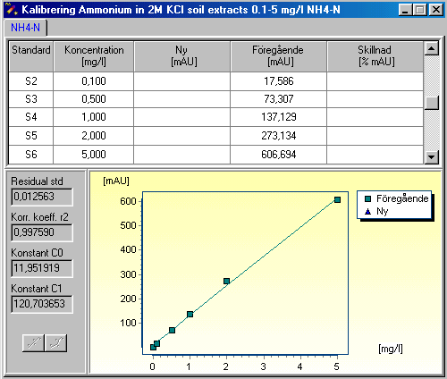
5.7 Results
Typical calibration data Range 0.1-5 mg/l
Note! Variations may occur due to temperature variations, pump tube conditions, reagent purity etc.
5.8 Calculation of results:
The results can be expressed as mg NH₄-N/kg sample using the following formula:

w = (C *V)/W

where:

w = mg NH₄-N /kg soil
C = concentration ammonium as mg/l NH₄-N
V = volume of the extract in ml
W = weight of the soil sample in g
5.8 Performance data
Repeatability (RSD) is 0.6 % for a 1 mg/l NH₄-N standard.
5.9 Remarks
- The standard deviation on the baseline on both water and reagents gives an indication of system flow and function. A high standard deviation (SD) can be caused by :
- poor pump tubes/flow
- too much dissolved air in the reagents
- undissolved matter in the reagents
- indicator solution not stable. It should be prepared 1 day prior to use.

Refer to the User manual for troubleshooting high standard deviations

- A wider measuring range can be obtained if 0.1M sodium dihydrogen phosphate, NaH₂PO₄ x H₂O
is added to the indicator reagent .
- To prepare, dissolve 13.8g NaH₂PO₄*H₂O and dilute to 1000 ml with distilled water.
- For example add 1.5 ml 0.1M sodium dihydrogen phosphate to 500 ml of reagent , to achieve a working range of 0-15 mg/l. Use non-linear calibration.
Note that the sensitivity of the method will decrease as the slope of the calibration curve is decreased.

6. Bibliography
- J. Ruzicka and E.H. Hansen, “Flow injection Analysis”, J. Wiley & Sons, 1981
- A. Ramsing, J. Ruzicka and E.H. Hansen, Anal. Chim. Acta, 114 (1980) 165.
- G. Svensson and T. Anfält, Clin. Chim. Acta, 119 (1982) 7
- EN ISO 11732: 1997 (and respective national standards):
- Water quality – Determination of Ammonium Nitrogen by Flow Analysis Methods and spectrophotometric detection.
- ISO 3696 Water for analytical laboratory use – Specification and test methods.
- ISO 8466 Water quality - Calibration and evaluation of analytical methods and estimation of performance characteristics

7. Revision history
Revision | Description of change | Date | Sign.
Rev. 1 | Initial revision | 2000-03-10 | KAx
Rev.2 | Remark about increased range using a buffered working indicator solution. | 2002-10-24 | KAx
Rev. 3 | Indicator stock solution (3.9), increased amount of NaOH from 10 to 50 ml of 0.01 M NaOH.  Changed absorbance range for adjusting indicator working solution | 2005-05-09 | KAx
Rev. 4 | New template  Modified Start up procedure | 2008-04-14 | KAx

8. Method/cassette specification
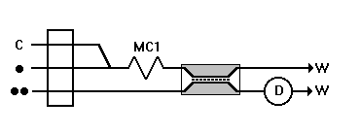
Flow scheme

Pump tube Code
C red/red
R1 () black/black
R2 () red/red
S grey/grey

Parameter settings
Wavelengths: M=590 nm, R=720 nm
Signal filtration: 1 s sliding mean
Injection volume: 40 μl
Injection time: 20 s
Fill time: 30 s
Measuring time: 50 s
Sampler, cup duration time: 30 s
Sampler, wash duration time: 20 s (high range)
Pump speed: 40 rpm
Evaluation: Peak height

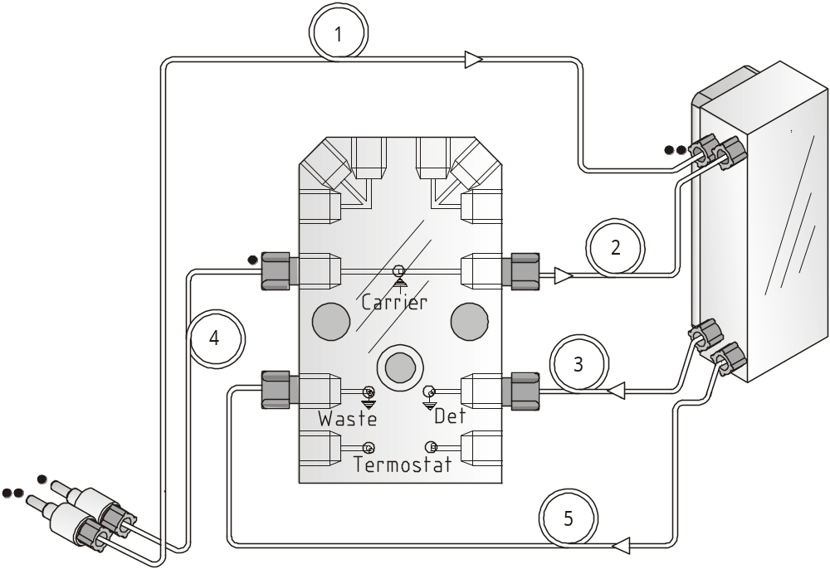Cassette configuration
Pos Tube Length (cm)/ID (mm) Part No
1 Teflon tube 21/0.5 10009898*
2 Mixing coil 30/0.5 10010376*
3 Teflon tube 7/0.5 10009892*
4 Teflon tube 9/0.5 10009897*
5 Teflon tube 15/0.5 50003138*
*(Available in Teflon Tube set 10012352 or 10010207)
Teflon tube color codes for cassette
NOTE! The method cassettes are configured in both hardware and software. If other teflon tubes or pump tubes are used than those specified, it may lead to longer/shorter measuring times. In that case the software method needs to be modified.

Connector ID (mm)
White 0.35
Red 0.5
Green 0.7
Dedicated Analytical Solutions
P/N No. AN5226 FOSS Analytical A/S Tel: +45 7010 3370
Issue No. 4 69 Slangerupgade Fax: +45 7010 3371
April 2008 DK-3400 Hilleroed E-mail: info@foss.dk
Company Reg.No. 7339 9815 Web: www.foss.dk

